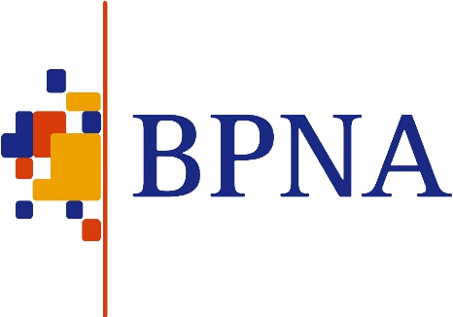
www.bpna.org.uk/conference/2020
British Paediatric Neurology Association’s 46th Annual Conference

BPNA 2020 Conference
Commercial Exhibitor Booking Form

PLEASE RETURN THIS FORM BY FAX TO +44 (01204) 528 394
OR BY EMAIL TO francesca.cassidy@bpna.org.uk

CONTACT DETAILS
Company Name:
Therapeutic Area (ie Epilepsy, Movement Disorders, etc):
Main Contact:
Address for correspondence:

Telephone:
Fax:
Email:

SPONSORED SYMPOSIUM
Yes / No We intend to apply to hold a sponsored symposium. We understand the closing date for submission of symposia abstracts is 9 September 2019 and that we will hear if we have been successful by the 9 October 2019.

STAND SPACE
Please delete as appropriate: |  | Gold £6,000 / Silver £4,000
Will you require a table? |  | Yes / No
Will you require any chairs? If so, how many?
Will you require an electric socket? (Subject to availability) |  | Yes / No  (All equipment to be PAT tested)
Additional equipment/special instructions/requirements?

REPRESENTATIVES

All named representatives must register their details via the BPNA website before booking a stand space. Please click the following link to register if you have not already done so https://www.bpna.org.uk/register.php

Names of representatives at the stand (registration here does not include access to the conference):
Name | Wed 29 Jan 2020 |  | Thurs 30 Jan 2020 |  | Fri 31 Jan 2020 | £
1. |  |  |  |  |  | Included (for paying exhibitors only)
2. |  |  |  |  |  | Included (for paying exhibitors only)

Additional stand staff charged at £50 per day:

SOCIAL EVENT BOOKINGS (not included in the above)
Name | Wed 29 Jan 2020 Reception @ £40.00 |  |  | Thu 30 Jan 2020 Dinner @ £60.00
 |  |  |  | Total amount |  | £

INVOICE DETAILS
Invoice address:
Purchase Order Number:
Stand space amount: | £
Social Events Costs: | £
Additional staff: | £
Total invoice amount: | £

Invoices for symposia will be sent after programmes have been selected. We will request a purchase order number for symposia if your programme is selected.

Please don’t forget to email your logo, web link and company description for inclusion on the
BPNA2020 app to francesca.cassidy@bpna.org.uk

