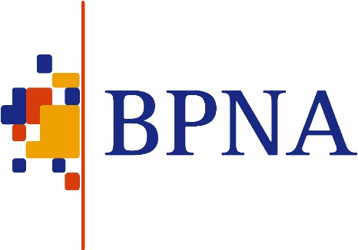
www.bpna.org.uk/conference/2023
British Paediatric Neurology Association’s 49th Annual Conference
BPNA 2023 Conference
Commercial Exhibitor Booking Form
PLEASE RETURN THIS FORM BY EMAIL TO francesca.cassidy@bpna.org.uk

CONTACT DETAILS
Company Name:
Therapeutic Area (ie Epilepsy, Movement Disorders, etc):
Main Contact:
Address for correspondence:

Telephone:
Fax:
Email:

SPONSORED SYMPOSIUM
Yes/No
We intend to apply to hold a sponsored symposium at BPNA 2023.

Closing date for symposia abstract applications is 19 September 2022. Allocation of sponsored symposia is on a competitive basis based on educational value. We will advise if your application has been selected by the end of October 2022.

Please submit your application online at www.bpna.org.uk/abstracts. The following information is required: proposed timetable, target audience, learning aims, proposed chairs & speakers, abstract text.

Invoices for symposia will be sent after selection. We will require a purchase order number for symposia if your programme is selected.

STAND SPACE
Please delete as appropriate: | Physical £6,000 / Virtual £3,000

If you have selected physical stand space:
Will you require a table? | Yes / No
Will you require any chairs? If so, how many?
Will you require an electric socket? (Subject to availability) | Yes / No  (All equipment to be PAT tested)
Additional equipment/special instructions/requirements?

REPRESENTATIVES

All named representatives must register their details via the BPNA website before booking a stand space. Please click the following link to register if you have not already done so https://www.bpna.org.uk/register.php

Names of representatives at the stand (registration here does not include access to the conference):
Name | Wed 25 Jan 2023 | Thurs 26 Jan 2023 |  | Fri 27 Jan 2023 | £
1. |  |  |  |  | Included (for paying exhibitors only)
2. |  |  |  |  | Included (for paying exhibitors only)

Additional stand staff charged at £50 per day for the physical conference and £25 for the virtual conference:

SOCIAL EVENT BOOKINGS (for physical conference only - not included in the above)
Name | Wed 25 Jan 2023 Reception @ £45.00 |  | Thu 26 Jan 2023 Dinner @ £65.00
 |  |  | Total amount |  | £

INVOICE DETAILS
Invoice address:
Email address to send the invoice to:
Purchase Order Number:
Stand space amount: | £
Social Events Costs: | £
Additional staff: | £
Total invoice amount: | £

Invoices for symposia will be sent after programmes have been selected. We will request a purchase order number for symposia if your programme is selected.

Signature:
Position:
Company:

Your BPNA contact is:
Francesca Cassidy
UK Education Manager
Telephone: +44 (0)1204 526002
Email: francesca.cassidy@bpna.org.uk

